EXPERIMENT NO - 6
AIM: Process Management: Synchronization.
TOOLS/SOFTWARES REQUIRED: Linux OS
THEORY:
Producer-consumer problem:
The producer-consumer problem is . The core issue is ensuring the producer doesn't add to a full buffer (overflow) and the consumer doesn't remove from an empty buffer (underflow), typically solved using semaphores to manage mutual exclusion and resource counting.
Semaphore:
A semaphore is . It manages concurrency without busy waiting by employing two atomic operations: wait() (or P) to decrement and signal() (or V) to increment the semaphore value.

Problem code and output:
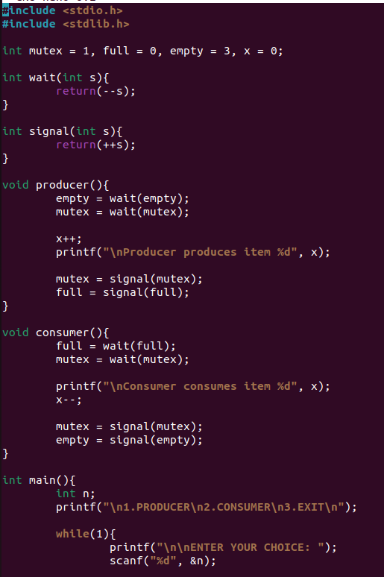

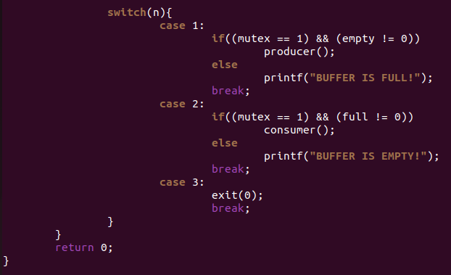
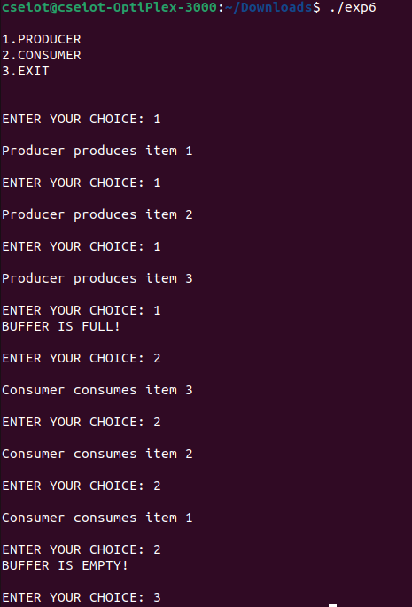
Problem code and output using stack:
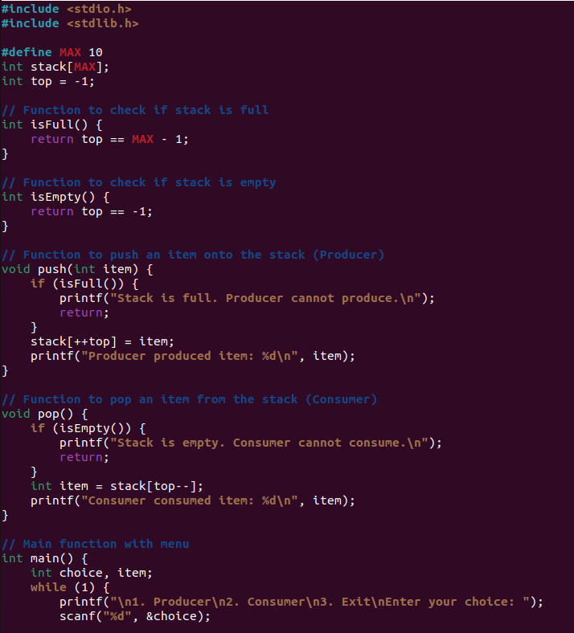
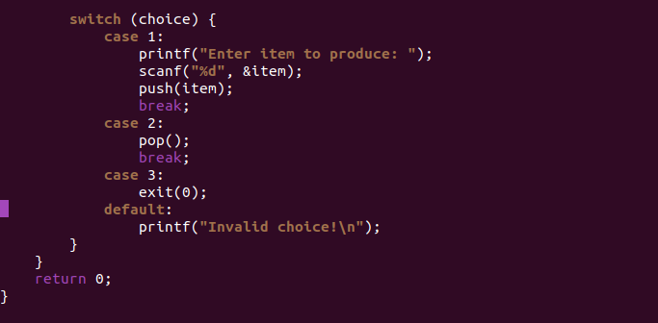
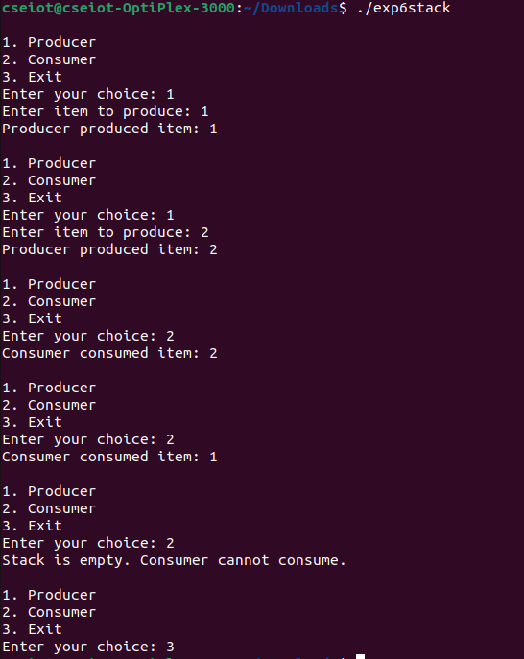

CONCLUSION: Hence, we have seen the Producer-Consumer problem in OS and implemented it in C, using both counter method and using a stack data structure.

